**Normalization Lab**

**NIKE Stores in Alberta**

The tables below are a description of the NIKE stores in Alberta that can demonstrate normalizations that’s not in the First Normal Form (1NF), In 1NF but not Second Normal Form(2NF), In 2NF but not Third Normal Form(3NF), and 3NF.

**Not In 1NF**

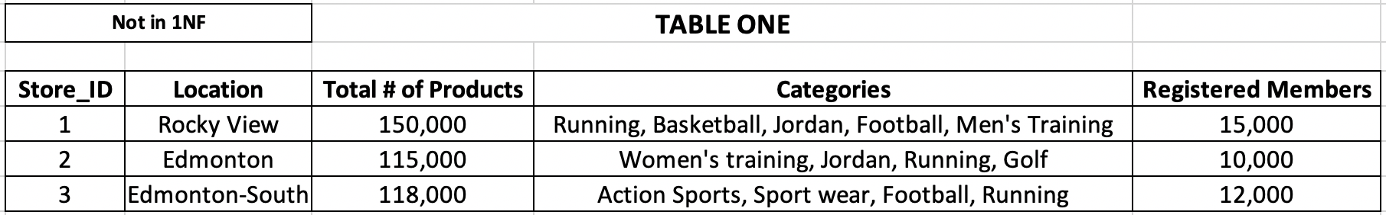

Table one is a demonstration of a database that’s not in 1NF. One of the rules of 1NF is that the attributes in a column should be single-valued. However, the attributes in the Categories column in table one are not single-valued. Since table one is breaking one of the rules of 1NF therefore, table one is not in the form 1NF.

**1NF Not In 2NF**

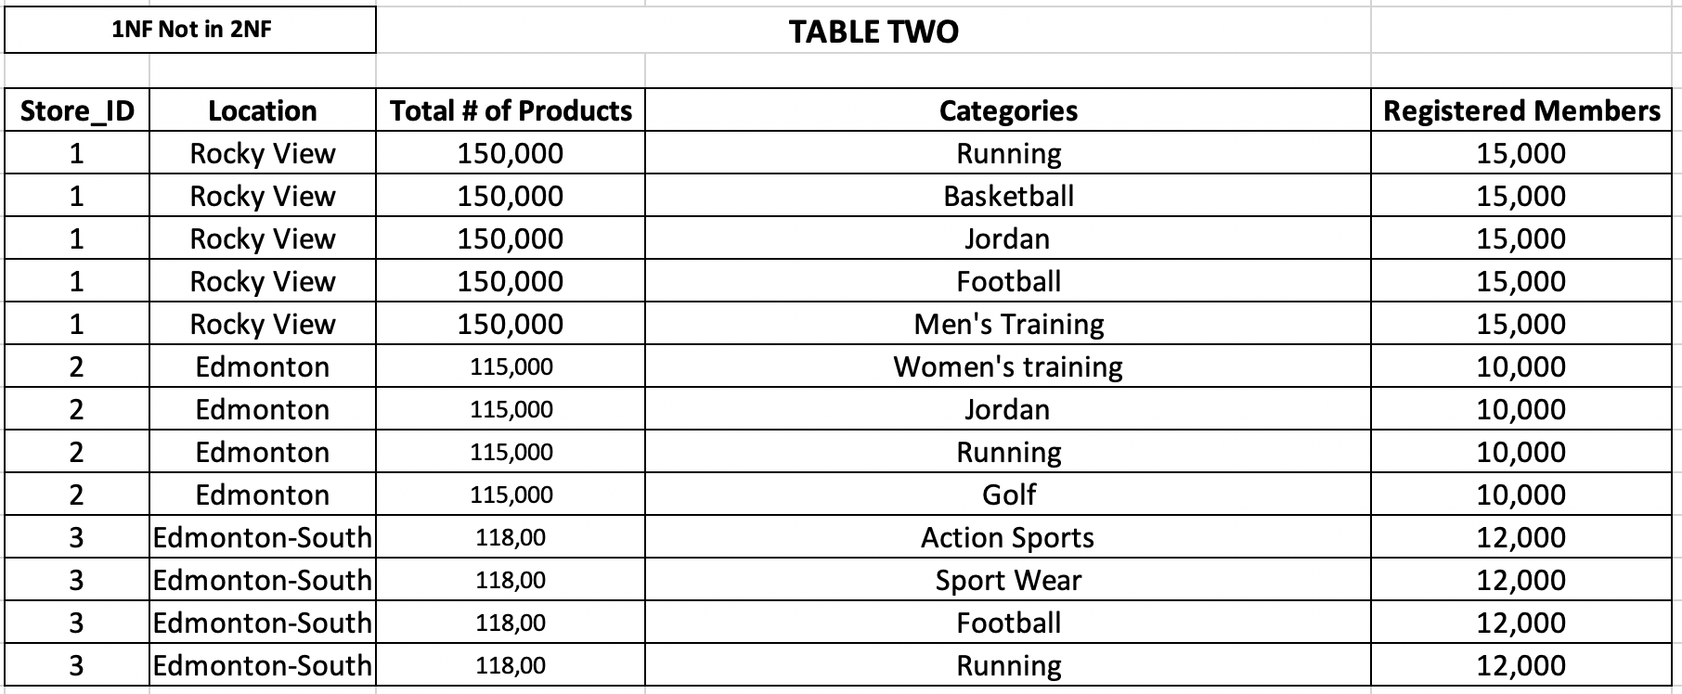

The above table is a demonstration of a 1NF database. The data or attributes in table two are single-valued. Besides, rows' order doesn't matter because the data isn't organized by priority, each column holds a specific type of data, and all the attributes have distinct names. Therefore, table two is in the first normal form because it satisfies all the first normal form requirements. But, table two is not in second normal form because there isn't any primary or foreign key in the table which means there isn’t any dependency.

**2NF Not In 3NF**

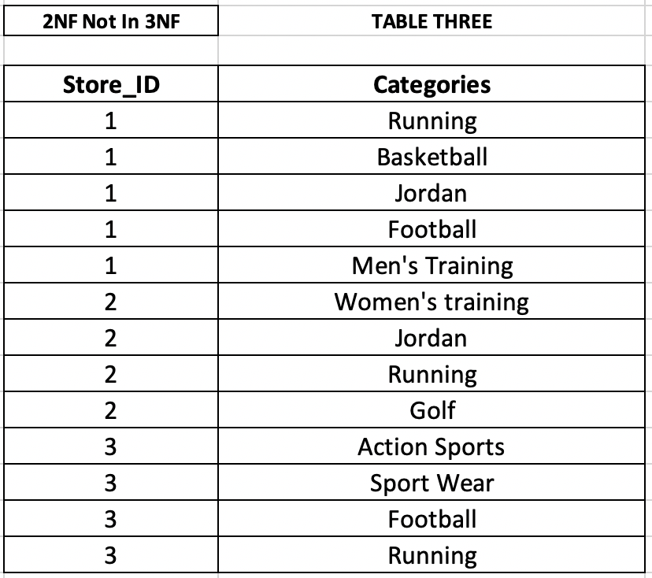

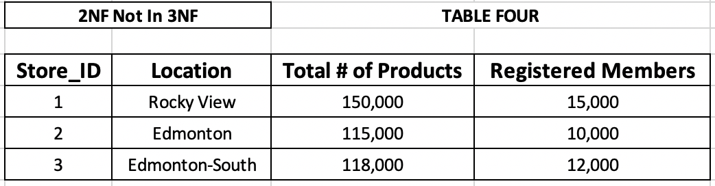

The above two tables are a visualization of a database that meets the criteria of 2NF. A 2NF database requires that tables are in 1NF, and every attribute depends on the table’s entire primary key which tables three and four together meet those rules. In table three, the attribute **Store_ID** is used as a primary key. In table four, the attribute **Store_ID** is used as a foreign key that makes the duplicated information disappear and the attribute **Store_ID** also represents each category of products too. Therefore, table three and table four are a perfect example to demonstrate a 2NF database but not 3NF because the attribute **Registered Members** depends on the attribute **Location**.

**3NF**

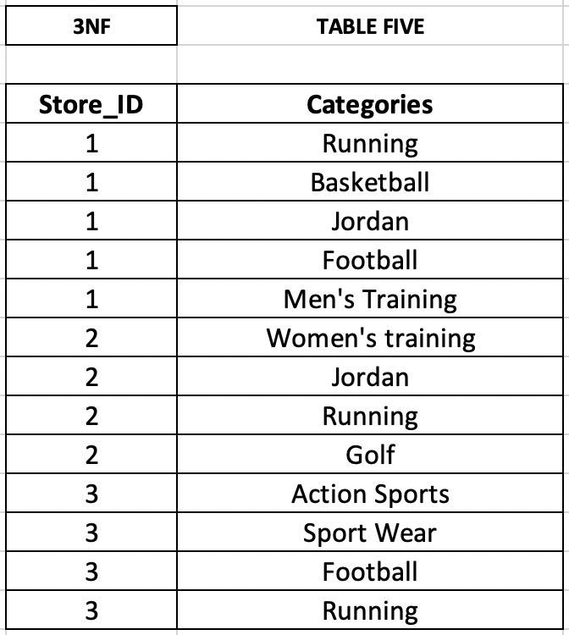

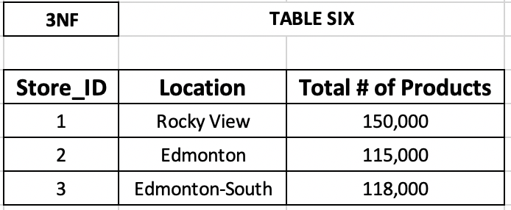

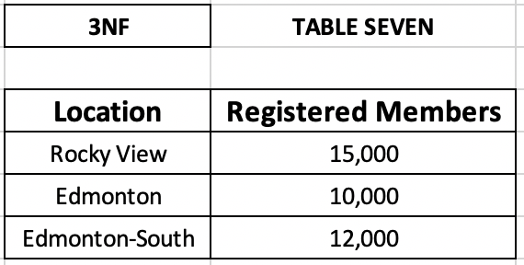

The above tables five, six, and seven are in the form of 3NF. The above tables meet the requirements of a 3NF database because the tables are in 2NF, and there are no transitive dependencies. In table four in 2NF, the attribute **Registered Members** had a dependency on attribute **Location,** and the attribute **Location** was not a primary key. Since the attribute **Registered Members** depended on the attribute **Location,** I made table seven where the attribute **Location** serves as a foreign key and in table six it serves as a primary key. The attribute **Registered Members** is now removed from the original table. So, now tables five, six, and seven don’t have any transitive dependencies; they are in the form of 3NF.